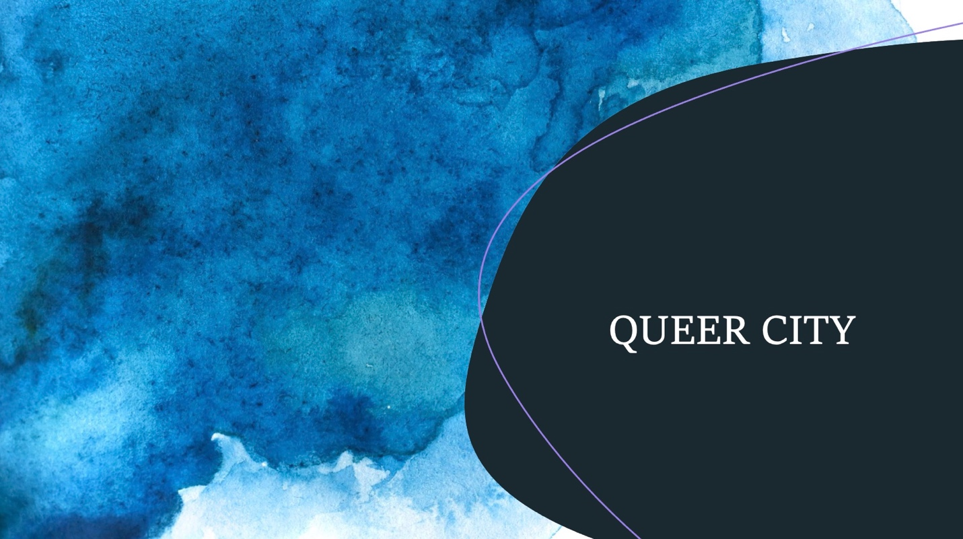

At present, approximately 20-30% of our patient population are a part of the LGBTQ+ community. In a recent survey, on average, each student reports that 31% of their patients are LGBTQ+.

With support from the Colin Powell fellowship, QUEER CITY is an effort to strengthen clinical training, in particular to provide competent and humble sexuality and gender affirming treatment at The Psychological Center. QUEER CITY is a project that aims to bring a series of events held in the Fall and Spring 2020-21 that will enhance multicultural competence, explore our role as clinicians, and open a dialogue in regard to gender and sexuality affirming care.

Queer City’s Objectives include growing our capacity as therapists-in-training to listen attentively and non-judgmentally, and to provide a supportive and affirming environment to explore questions of identity and selfhood. We are committed to learning to provide culturally humble and LGBTQ-affirmative care. Our training will offer in-house therapists opportunities to grow their competency in working with, and being mindful of individual experiences at the intersection of gender, race, ethnicity, sexual orientation, religion, and SES.

Current programming has included:
- Student representatives from The Harvey Milk High School who spoke to therapists-in-training about LGBTQ+ youth identity and mental health. Students shared their stories and experiences in the field of mental health, including experiences of support, as well as the wrongful assumptions they endured in their work with therapists. Students shared their wishes for what current or future therapists would know.
- Representatives from the student group q&a (queers & allies) conducted an in-service presentation to students & faculty on September 28^{th,} 2021. Topics discussed included: gender/sexuality affirming use of language, research on risk in the LGBTQ+ community, intake and assessment protocols, & case examples.

Future programming will include:
- A presentation by Randall Leonard (they/them), a Black, pansexual, genderqueer individual serving community as a social worker clinician and healer who will speak from a number of lenses about the intersectionality between race, culture, gender and sexuality
- A gender-affirming surgery letter-writing tutorial
- A hormone & Endocrinology in-service
- A paper presentation from City graduate Hannah Wallerstein who recently edited a section for the Psychoanalytic Study of the Child on working with trans children, in which four psychoanalytic thinkers with varying positions wrote short essays, and dialogued together on difficult clinical questions
- & MORE! Stay tuned!

